Testing TurboWin format 101 (semi compressed) output

Making a format 101 obs for testing:

- Install TurboWin 5.5 beta
- Enable the format 101 (compression) code mode option. On your desktop right click the TurboWin 5.5 shortcut icon and select properties. Add “-2” on the target line, see example below (one time). Note: Observations made by ships with recruiting country is The Netherlands are by default in compressed mode, not necessary to add the "-2" option

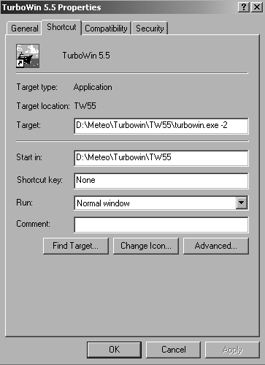

- Insert all the appropriate station and E-mail settings. Especially: “Maintenance -> Station data -> code form”; select: "format 101 (compressed)" (one time). Restart TurboWin if required.
- Insert all the (test)values on the TurboWin input pages
- If all values entered make a TurboWin main screen dump (Print Scrn) and save the dump if necessary. Note: the FM13 counterpart obs on the status line (bottom screen) is not visible if recruiting country UK or Australia
- Select one of the enabled output options (e.g. "Output -> Obs by E-mail (OLE)") to compile a format 101 obs. For decompressing afterwards you must select: “Output -> Obs to custom file”, see next bullet
- To decompress a format 101 obs you must follow the following procedure: first select in TurboWin: “Output -> Obs to custom file”. Write the compressed obs to the TurboWin sub folder compression with HPK_format_101.txt as file name (e.g. see example below; [TurboWin root dir] in this example = "D:\Meteo\Turbowin\TW55")
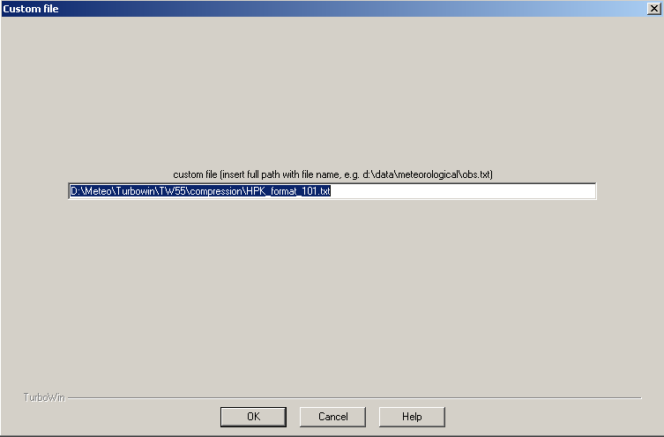

- Run [TurboWin root dir]\compression\test_decompression.bat
- Compare the inserted data (see screen dump) with the compression algorithm input data (file: format_101_memory.txt) and the decompressed data (file: do_not_send_decompressed_FM13_obs.txt and file: decompression_log.txt).
Note1:
Please keep in mind that the FM13 coded decompressed message is not always exactly a copy of the TurboWin FM13 message. E.g. in TurboWin, to avoid any misinterpretation in the receiving systems, there is always a minimal number of groups present and if necessary filled with “/”. In the decompressed FM13 obs several “/” groups are skipped. In an operational setting format 101 messages will be put as bufr messages on the GTS (so not FM13)
Note2:
In this TurboWin test environment the FM13 coded decompressed obs (file: do_not_send_decompressed_FM13_obs.txt) will always have call sign "WWWW"
- Check the appended IMMT log (file immt.log)

Input file (memory dump) compression algorithm:
[TurboWin root dir]\compression\format_101_memory.txt. Four columns in this file. The first column gives the (internal use) element number. The second column with a 0 or 1 indicating the element is present (1) or not (0). Third column the value of the element and the last column the name of the element

Output file compression algorithm:
[TurboWin root dir]\compression\HPK_format_101.txt

Output files decompression algorithm (only for testing):
[TurboWin root dir]\compression\do_not_send_decompressed_FM13_obs.txt
[TurboWin root dir]\compression\decompression_log.txt

Output IMMT file
[TurboWin root dir]\log\immt.log

Use(ful)(d) documentation:
- codes_info_draft_v2.doc (SMD input counts also for format 101)
- WMO_306_code_tables.pdf
- SHIPS_CODE_CARD.pdf
- WMO306_vl2_BUFRCREX_CodeFlag_en.doc
- E-SURFMAR_VOS_formats.pdf
- IMMT-5-JCOMM-4.pdf

Last update: 14-10-2014

